Celebrate Teachers and Staff
with a Thank You Donation!
It helps the Dutchess BOCES Education Foundation enhance educational experiences for all students.
Looking for a unique way to thank a special teacher or staff member? It’s simple! Make a tax-deductible donation to the Dutchess BOCES Education Foundation to support teacher mini grants and student scholarships.
The honoree will receive a personalized letter from the Foundation telling them about your donation and your desire to recognize his/her exceptional impact.

Honoree’s Name __________________________________________________________
School ____________________________________________________________________
Your Name ________________________________________________________________
Address ___________________________________________________________________
Phone Number ______________________ E-mail _____________________________
Personal Message (optional)
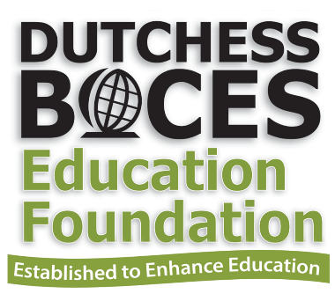

Donation amount ($5 minimum, please) _______________
Make checks payable to Dutchess BOCES Education Foundation and mail to:
DBEF, Attn. June Markle, 5 BOCES Road, Poughkeepsie, N.Y. 12601
Or drop it off in the main office of your child’s school.

